42.51: a) 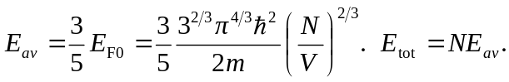
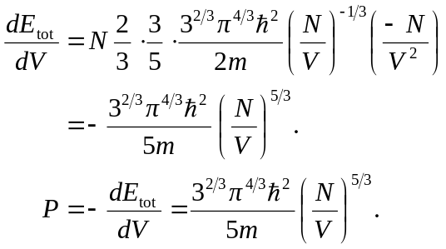
b) 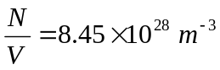
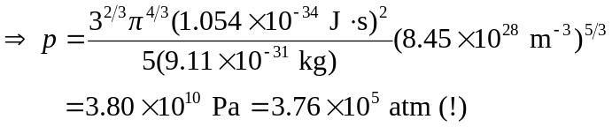
c) There is a large attractive force on the electrons by the copper ions.

